SVM output analysis
Make it prettier
Classification Report Table:
 | Precision | Recall | F1-score | Support
0 | 0.637658 | 0.704819 | 0.669559 | 5146.0000
1 | 0.568380 | 0.558576 | 0.563435 | 7247.0000
2 | 0.662067 | 0.723707 | 0.691516 | 14253.0000
3 | 0.922027 | 0.853173 | 0.886265 | 23354.0000
Accuracy | 0.758300 | 0.758300 | 0.758300 | 0.7583
Macro Avg | 0.697533 | 0.710069 | 0.702694 | 50000.0000
Weighted avg | 0.767398 | 0.758300 | 0.761655 | 50000.0000

Confusion Matrix
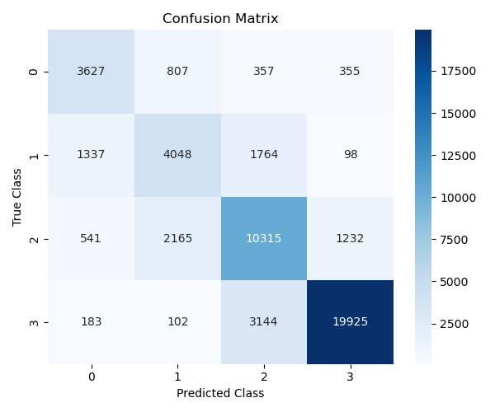

Process:
Create a dataset object that manage all the dataset preparation. We manage the features, which there will be the RGB and NDVI values of the images. Then we create a model object to manage everything about the model. We use Radial Base Function Kernel which make our model non-linear and a regularization of 1.0 (default). Then using matplotlib, create the confusion matrix.
Results:
The model and data management were simple so we couldn’t expect too much, with end up with an accuracy of 75.83%. This can be of course upgrade if we fine-tune the regularization, and better process of data. For time and resources management, we subsample the data to make it run faster and use less computational resources, choosing the data at random.

